Assignment No. 12
- TITLE : Write a Java program to create a student class with details like Roll no, Name, Marks of five subjects, percentage, class (First, Second, etc) have following functions: parameterized constructor, destructor, Display and Calculate percentage and grade.

- CODE:
import java.io.*;
import java.util.*;

public class Student {
String name;
int roll;
int marks[];
double percentage;
String grade;
Student(String n, int r, int m[]) {
name = n;
roll = r;
marks = m;
percentage = calculatePer(m);
grade = calculateGrade(percentage);
}
void display() {
System.out.println("Name : " + name);
System.out.println("Roll No : " + roll);
System.out.println("Percentage : " + percentage);
System.out.println("Grade : " + grade);
}
double calculatePer(int m[]) {
int sum = 0;
for (int i = 0; i < m.length; i++) {
sum += m[i];
}
percentage = (double) sum / m.length;
return percentage;
}
String calculateGrade(double p) {
if (p >= 90) return "A";
else if (p >= 75) return "B";
else if (p >= 60) return "C";
else return "D";
}
protected void finalize(){
System.out.println("The space alloted to objects is destroyed!");
}
public static void main(String args[]) {
Scanner sc = new Scanner(System.in);
System.out.println("Enter name of student : ");
String n = sc.nextLine();
System.out.println("Enter roll no. of student : ");
int r = sc.nextInt();
int a = 5;
int m[] = new int[a];
System.out.println("Enter marks of " + a + " subjects : ");
for (int i = 0; i < a; i++) {
m[i] = sc.nextInt();
}
Student s1 = new Student(n, r, m);
s1.display();
sc.close();
}
}

Output –
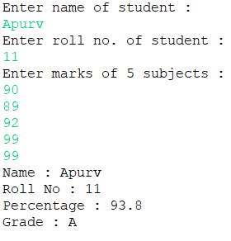

- Conclusion – In this assignment, we’ve implemented java program on implementation Of parameterized constructor, destructor for Student class and also displayed percentage and grade of student.

